Basic steps for git setup

1 make a new folder named CN_project somewhere in your machine

2 Right click on the folder and select Git bash

3 a command window will open up and you need to clone the repository by –

git clone <https://github.com/guneetsinghmehta/CN_project.git>

This will clone the remote repository .

4 there are four branches on the repository –

master, guneet, anuj and sanika –

master is for the backup code, please do not commit to this branch, I will handle this branch. The respective names are for the designated users

5 So now you have the code that you want , you need to switch to your branch

Command – git checkout anuj 🡪 for anuj , replace ‘anuj’ with sanika for the branch ‘sanika’

6 The steps 1 to 5 are one time operations. From step 6 onwards- it is the day to day operations on the github

**Day to day operations**

**Start your day in the following way**

1 pulling the repository – Important

Right click on your folder and select git bash and on the command window type – git pull . this will reflect all changes in your local copy

2 switching to your branch

Git checkout anuj / Git checkout sanika

3 Now do your work in eclipse – save the changes –make small changes .

4 Once you are sure that the code is good with no bugs, open git bash terminal and type

git gui

This will open up a window – showing all the changes

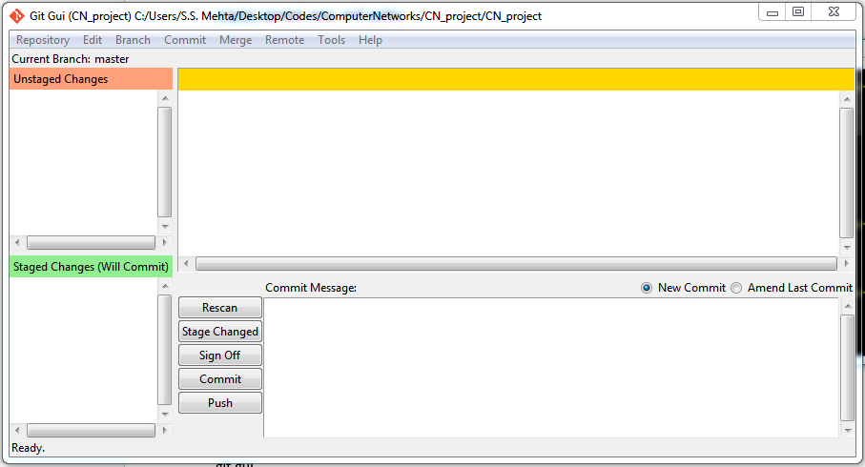

All your changes will be reflected in the yellow window, files which are changes will be shown in the red window.

1 Write good comments in the comment message window – this is important for other people to understand what changes you have made to the code.

2 then click Stage changed

3 Press commit – to commit the changes

4 at the end of day press push. To push all your commits to the remote repository. A window will pop up asking your github username and password, type it in and you are done.

**Easy right !!! Now some caution !**

**Caution**

1. Work only on your branch

2. whenever you want to get someone else’s code just type – This should not ideally happen – may lead to serious mess ups -

git checkout branchname.

If you want to clone the entire work of someone else- you need to-

1. Git checkout targetbranchname
2. The changeswill be reflected in the files in your local machine
3. See the code- dopy it somewhere else like notepad
4. Git checkout mybranchname
5. Open the same file in eclipse and paste the copied contents

3. Never make commits to other branches